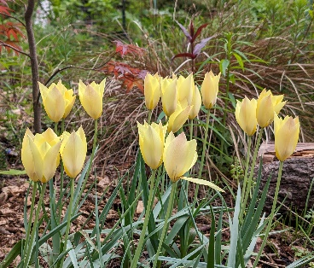
Sign up if you would like to get involved in
Panorama’s Pollinator Garden

Your name | Email address: please print clearly so we get it right!

