Panorama’s Pollinator Garden

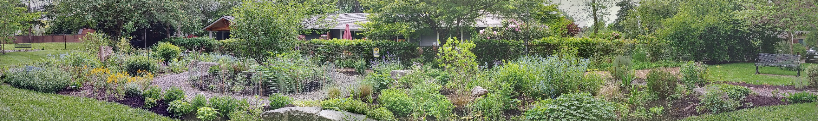

Created in 2015, the Pollinator Garden is a demonstration garden
for plants that attract and provide a home for the native butterflies,
bees, and hummingbirds of the Puget Sound lowlands. Panorama
volunteers design and care for the garden throughout the year.

