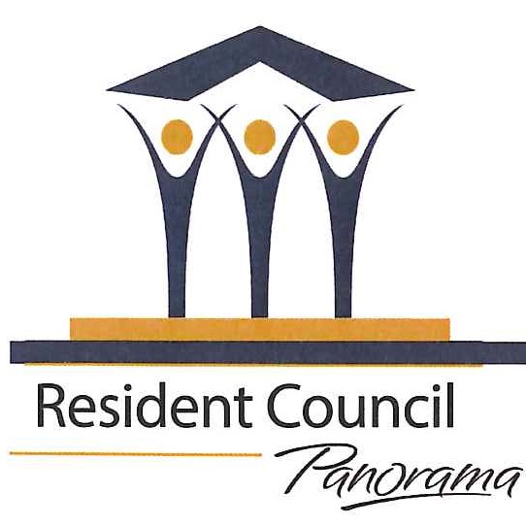 ACTIVITY GROUP ANNUAL REPORT FOR FY 2025-26

- Resident Council Sponsored Activity: Panorama Green Team

- Purpose: To encourage residents and the Corporation to be environmentally sensitive, use energy and water resources wisely and, through education, reduce our “carbon footprint” and create a healthier place to live and work.

- Organizational Documents (list and attach):

- Overview visual of Panorama Green Team Activities
- Leadership “succession plans”
- Green Team Budget for FY 2027
- Recent Green Team Programs and Patterns of Attendance

- Officers/Leaders (indicate expiration of term):

We do not have bylaws or formally elected formal officers. Each year we have a check-in with Steering Committee leaders and chairs of volunteer teams to see if they want to continue in their role. This past year, we completed written job descriptions for each major position.
We have a chair, a vice chair, a recording secretary, a communications secretary, a treasurer, and several team leaders of volunteers, such as the leaders of the “Recycling Buddies” and the coordinator of the Pollinator Garden. See Attachment (b) for that list. For our succession plan, we have identified individuals to serve as “back-up” volunteers if the identified leader cannot attend a meeting or is unavailable for a specific task.

- Who has authorization to approve spending?
Our treasurer, Candy Charlwood. Jean MacGregor serves, if needed, as the “back-up” to Candy.
5a. Current balance in your Activity Fund: $151.97. See Attachment (c) which summarizes both our Resident Council Account and our Activity Fund.

5b. How will the funds be used in the 2026 – 2027 year? We have not yet discussed any upcoming needs/expenditures from our Activity Fund. We see it as a fund for light refreshments if we plan to serve them at a social function for Green Team members (as we have in the past) and for unexpected expenses which might arise.

5c. Report of the Green Team’s Resident Council Appropriation is included here in Attachment (c). This spreadsheet summaries FY 26 spending and FY 27 approved spending plan.

- Membership: Number of members (or regular attendees)
Our mailing list includes over 200 Panorama residents. A small number are Panorama applicants who have signed up at the Activity Fair to be on our mailing list. Regular attendees of monthly programs vary from 20 to over 150 depending on the nature and location of the Green Team program. Our field trips often have wait-lists. See Attachment (d) for attendance notes at programs.

6a. How many of your members are NOT Panorama residents?
Robin Tuttle – Panorama applicant, is a regular volunteer in the Pollinator Garden
A small number of applicants attend our programs.

- Space: If activity has its own space: N/A

- Describe activities (programs, projects) since last year’s annual report.

See Attachment (a), the visual of the Green Team’s Activities at Panorama. Activities will be summarized in the categories featured on this visual.

- Educating Residents
- Lectures and films offered to entire resident population
Please see Attachment (d) for the list of recent Green Team programs and patterns of attendance.

- Field trips to sites of interest offered to entire resident population

November 2025: Mushroom Foraging and Cooking, organized by Peggy Mee.
November 2025: Kennedy Creek Salmon Trail, led by Cleve Pinnix
November 2025: New Traditions Fair Trade: Tour, shopping, and lunch
March 2026: Nature Walk at Billy Frank Jr. Nisqually National Wildlife Refuge
April 2026: Birding at the “Inspiring Kids Preserve” of Capitol Land Trust led by Jean MacGregor
May 2026: Nature Walk at Billy Frank Jr. Nisqually National Wildlife Refuge led by Cleve Pinnix
May 2026: Local Bird Walk on the Chehalis-Western Trail with Jean MacGregor and local birder Lisa Genuit.
June 2026: Bergford Family Farm and Gardens, organized by Peggy Mee.

- Tips for proper recycling and education about solid waste:
- The Green Team published a new, updated tri-fold brochure with information about recycling. The brochure is available in prominent plastic holders at each recycling center on campus and was distributed at the Activity Fair.
- The “Recycling Buddies” are volunteers who educate residents in the Quinault and at the recycling centers about appropriate material to recycle.

- Green Team website, the Green Team group on Kya, and the Green Team Page in the Panorama News. The Green Team updates and educates residents via all of these modes of communication. The website address is: https://panoramagreenteam.org/

- Panorama Tree Guide: Two GT volunteers continue to work on a new digital Panorama Tree and Shrub Guide which will eventually be available as a smartphone App.

- Green Team brochure: The Steering Committee revised and updated our tri-fold Green Team brochure for the Activity Fair and we make it available at Green Team programs and functions.

- Involving Residents in Green Team Projects

- Encouraging Resident Involvement:

- March: The GT participated in Panorama’s annual Activity Fair.
- Year round: The GT maintains an email list of 200+ residents interested in receiving announcements of upcoming events and volunteer opportunities.

- Caring for the Pollinator Garden: 13 Pollinator Garden volunteers continued to care for the garden with new plantings. They also created and placed over 100 small signs to identify the pollinators. Unfortunately, in December we lost Bob Findlay, our coordinator. Jean MacGregor assumed the coordinator position for the 2026 growing season.

- Monitoring Recycling Centers: About a dozen GT volunteers “Recycling Buddies” regularly monitor the recycling centers; they remove inappropriate trash items that are not recyclable and they educate residents about proper recycling practices.

- Litter/Trash Pick-up along roads near Panorama continued on one Saturday morning a month in good weather, with an average of 5-6 volunteers collecting trash in collaboration with the city of Lacey.

- Paper shredding days were held in September and April. GT volunteers publicized and staffed the collection of paper to be shredded.

- Supporting local environmental organizations:

- August: GT volunteers encouraged residents to attend the annual fund-raiser of the South of the Sound Community Farm Land Trust and arranged for a Panorama bus for those attending.
- April: Panorama and the GT co-sponsored a luncheon at 1751 to feature and support the Capitol Land Trust. Panorama matched donations to the CLT up to $500.00.

3.Supporting Sustainable Practices at Panorama

- Co-management of recycling: GT leaders continue to collaborate with management on operating our two collection centers for recyclable items. GT volunteers continue to collect organic, compostable organic waste from two floors of the Quinault.
- Solar panels on campus buildings: GT Walking Tour leaders feature these in their Sustainability Walking Tours.
- EV Charging Stations: GT Walking Tour leaders feature these also in their Sustainability Walking Tours.
- Green Landscape Care: GT leaders meet occasionally with Adam Hill, the Grounds Manager to learn about Grounds activities and issues. They continue to encourage:
- Leaving more leaves in garden beds to support invertebrate life and bird life year-round, but especially in winter months.
- Continuing to phase in more electric lawn-care equipment, to reduce our carbon footprint and to reduce the highly dangerous air and noise pollution emitted by the two-cycle engines in use.

- New initiatives led by Green Team leaders
In March 2026, Green Team leaders convened about 50 interested Green Team members and other interested residents to share the work of SSAFE, Senior Stewards Acting for the Environment, a national network of resident groups at life-plan communities who work to educate fellow residents and staff about sustainability and sustainable practices, especially those that reduce our carbon footprint. We convened interested Green Team members to introduce the SSAFE network and its possible benefits to Panorama, and we asked for feedback about the Panorama Green Team joining SSAFE. The response was enthusiastic. The Steering Committee continues to consider joining SSAFE, but a higher priority at this time is strengthening our volunteer base.

