REDUCE AND RE-USE
before recycling.

Learn about and use our alternative transportation systems. Walk, bike or trike on campus, or use Panorama’s Resident Transit.

Request a work order (#4205 or through Kya) to replace incandescent light bulbs with warm LED lights.

If you have outside lights at night, put them on a motion or light sensor or timer, to make sure they’re off during daylight. Use outdoor lighting responsibly, so that it meets the needs of people to see at night, avoids harmful effects on wildlife, protects our night sky and conserves energy.

Put your computer and entertainment center on surge protectors and turn everything off when not in use.

Consider reducing the amount of meat and dairy in your diet.

Conserve water and energy.

These are just a few ideas.
We have lots more and you
can help us add to them!

CARE FOR IT, IT’S OUR ONLY HOME.


The Panorama
Green Team
invites you to
join us.

Your actions count.
TOGETHER we do make a difference.
PanoramaGreenTeam.org
“It is a wholesome and necessary thing for us to turn again to the earth and in the contemplation of her beauties to know the sense of wonder and humility.”
—Rachel Carson, The Sense of Wonder

We offer educational programs which normally take place at 3 p.m. the 2nd Tuesday of the month in the Quinault Auditorium, but check Panorama News for changes in time or location.
The Green Team invites you to attend these programs. Also, there are lots of ways you can help. Pick the projects that fit your interests and strengths.

(No programs in July, August, or December)

For questions about our projects or how you can help, visit PanoramaGreenTeam.org
or email PanoramaGreenTeam@gmail.com

Pollinator garden
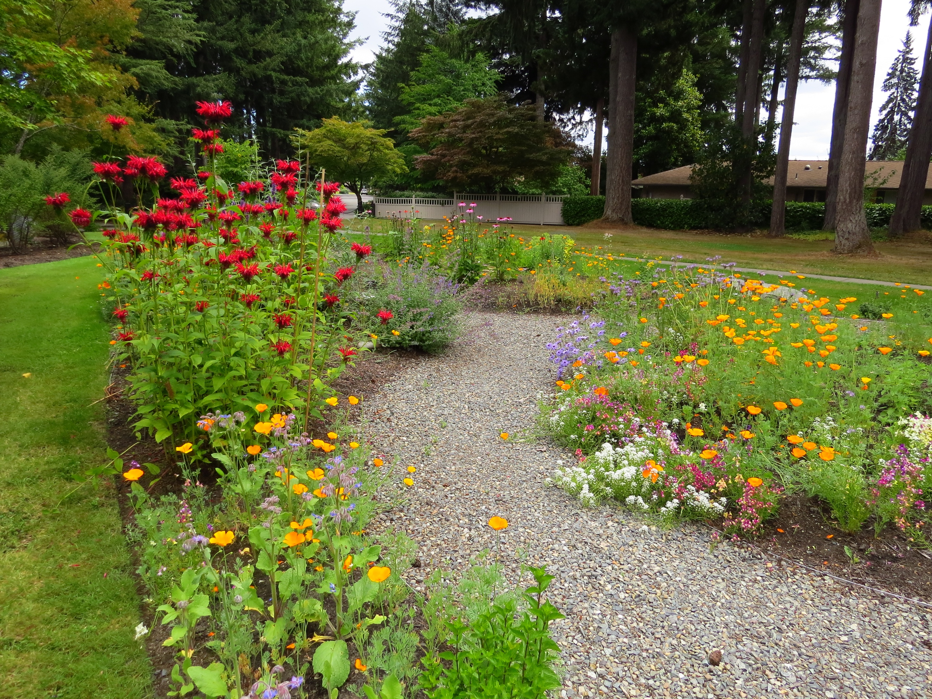
A few suggestions for
good stewardship


